|  |  |
| --- | --- |
|  | Foundation Activity 1 Conductivity and Breadboards |

Contents and Learning Outcomes

Students will,

1. Test the conductivity of different materials
2. Map the conductivity between points on a solderless breadboard[1]

This activity should take **~1 hour (1.5 hours recommended)** to complete:

Materials and Costs per Student 2

Lesson 2

Activity Overview (2 minutes) 3

Introduction to Electricity (5 minutes) 3

Conductivity (5 minutes) 4

Test Materials (20 minutes) 4

Discuss Results (5 minutes) 4

Map Breadboard Connections (10 minutes) 5

Breadboard Disassembly (10 minutes) 5

Debrief Discussion (5 minutes) 6

Challenge and Explore 6

Frequently Asked Questions 6

Materials and Costs per Student

Assuming one kit of parts per student:

|  |  |  |  |  |
| --- | --- | --- | --- | --- |
| Item | Qty. | Cost per Student1 | Expendable2 | Supplier |
| Piezo Buzzer 5V 12mm | 1 | 0.19 |  | [AliExpress](https://www.aliexpress.com/item/10pcs-5v-Active-Buzzer-Magnetic-Long-Continous-Beep-Tone-Alarm-Ringer-12mm-MINI-Active-Piezo-Buzzers/32620122626.html) |
| Jumper Cables MM MF FF 10cm | 3 | 0.06 | yes | [AliExpress](https://www.aliexpress.com/item/Free-shipping-Dupont-line-120pcs-10cm-male-to-male-male-to-female-and-female-to-female/32714431608.html) |
| Breadboard 400 point | 1 | 1.49 |  | [AliExpress](https://www.aliexpress.com/item/Free-Shipping-10pc-Quality-mini-bread-board-breadboard-8-5CM-x-5-5CM-400-holes/1785291644.html) |
| Breadboard Power Supply, 5V/3.3V* | 1 | 0.75 |  | [AliExpress](https://www.aliexpress.com/item/Best-price-10pcs-lot-MB102-Solderless-Breadboard-Power-Supply-Module-3-3V-or-5V/32505402973.html) |
| 9V Ni-Mh 450mAh | 1 | 5.17 |  | [AliExpress](https://www.aliexpress.com/item/Wholesales-8pcs-lot-ETINESAN-9v-450mAh-Ni-MH-Rechargeable-9-Volt-NiMH-Battery-Batteries-use-Camera/32535390438.html) |
| ****Total Cost per Student**** |  | **$7.66 CAD** |  |  |

1. *Currency is CAD, 2017-06-10. Assuming one set of parts per student.*
2. *Likely to be broken or lost during the activity.*

*\*This activity can be done by connecting the buzzer directly to the battery, without using a power supply, if you have suitable battery snaps and the buzzers can handle 9V directly.*

Each student should also get one printed copy of the activity handout.

Common household/classroom materials for conductivity testing such as:

* Metal wire
* White-board
* Pencil (wood)
* Pencil (graphite)
* Crayon
* Coin
* Paper clip

Lesson

Before class: gather materials for conductivity testing; build the testing circuits; print student handouts. The focus of this activity is not on building the testing circuit. The students should understand how it works, but it is best to assemble them for the students in advance to save time for testing/discussion. The test circuits can be built by connecting the buzzer directly to the 9V battery using jumper wires, or it can be constructed using a breadboard:

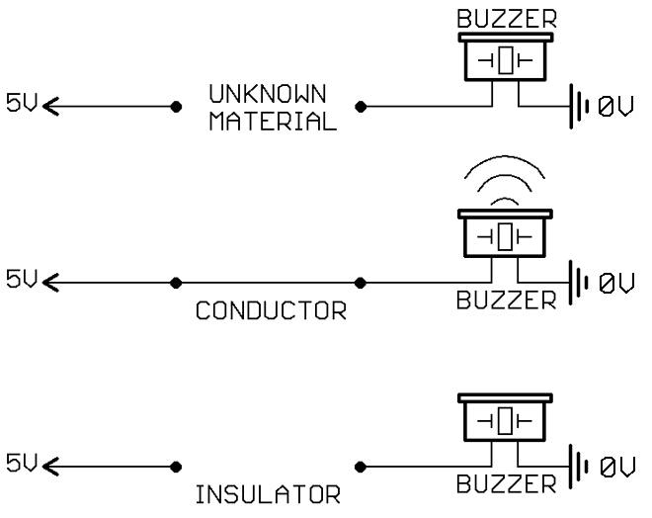

|  |  |
| --- | --- |
|  |  |

**Bold text** indicates directions or notes specifically for the instructor.

Activity Overview (2 minutes)

Today, we’re going to:

1. Introduce the concept of electricity
2. Learn about conductivity
3. Test different materials for their conductivity
4. Map breadboard connections
5. Disassemble a breadboard

Introduction to Electricity (5 minutes)

**The following is an overview of the fundamentals of electricity that should be discussed with students:**

* Controlling the movement of electrons in materials
  + There are electrons in everything
  + Electrons move more easily in some materials than others
  + We can control these electrons to power things (e.g. lights, movement) and communicate information
* Rock slide analogy of electricity
  + The height of the hill represents voltage
  + The sliding rocks represent current
  + Trees represent resistance
  + Current always flows from high to low voltage

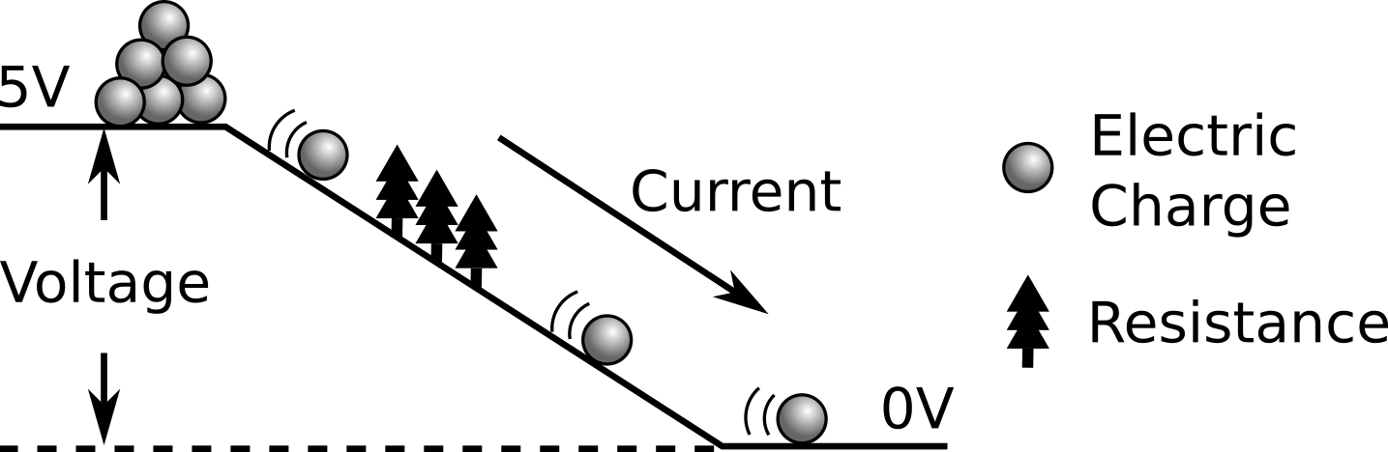

* What happens to current when we increase the voltage? **(draw a higher hill)**  
  A: current increases
* What happens to current when we increase the resistance? **(draw in more trees)**  
  A: current decreases

Conductivity (5 minutes)

**Discuss the following key points with students:**

* Conductivity is how easily electric charge can move in a material
* Conductors, such as metal, allow charge to move easily
* Insulators, such as plastic, do not allow charge to move

Test Materials (20 minutes)

We are going to use a buzzer circuit to test whether different materials are conductors or insulators.

**Begin by drawing the buzzer circuit on the board. Explain how the circuit is built, and that if a material is a conductor charge will flow and the buzzer will sound. Ask the students to test different materials, filling in the tables on their handouts with their findings.**



Discuss Results (5 minutes)

**Ask students to discuss the following:**

* Share results and write a list of conductors and insulators on the board
* Try to spot some similarities among the different conductors (A: mostly metals), and among the different insulators (A: mostly plastic or organic)

Map Breadboard Connections (10 minutes)

**Draw the top part of the breadboard on the board:**

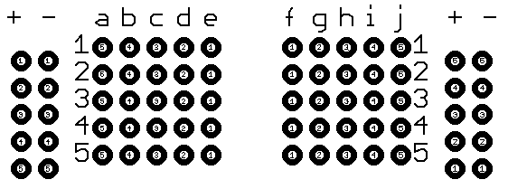

**Show an example testing the conductivity of one hole to the holes surrounding it on the board. Ask students to test which of the holes conduct together on the breadboard and draw the results on their handouts or a scrap piece of paper. The students should use lines to show which of the dots are connected. When they’re done testing, every dot should be connected with a line to show conductivity in the following manner:**

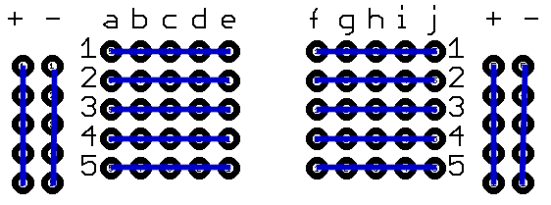

Breadboard Disassembly (10 minutes)

How do you think electrical connections are made inside the breadboard? What connects the points in one line? A: metal strips. Each of these metal strips makes a conductive point where parts can be connected together.

**Disassemble the breadboard in the following manner to demonstrate how connections are made inside a breadboard:**

* **Pull the adhesive backing off the breadboard to expose the metal strips**
* **Pull out one of the metals strips to show the small clips used in each hole**
* **Pass the opened breadboard around so the students can see**

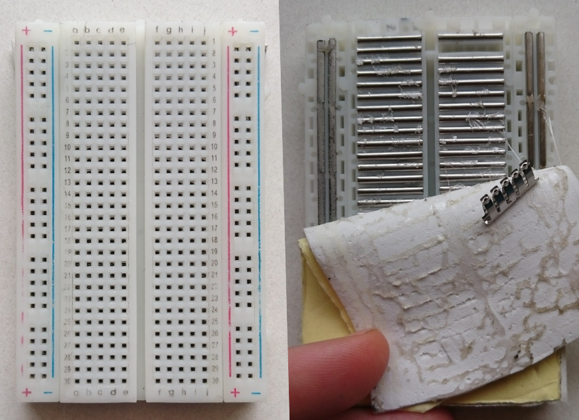

Debrief Discussion (5 minutes)

**Encourage a discussion among the students for them to share their thoughts on the activity.**

Today we tested the conductivity of different materials and explored how breadboards work. Why is this important? What applications does this have? Possible answers:

* Every circuit uses conductors and insulators to control electricity!
* Breadboards allow us to build circuits without using special tools.

Challenge and Explore

**If a student completes the lesson early, evaluate their understanding by asking them to try the following:**

* Is there anywhere on the breadboard where it is conductive across a row AND up and down a column? A: no.
  + Skill: differentiating conductors and insulators
* **If the testing circuits were not built on the breadboard to start with:** Try rebuilding the conductivity testing circuit on the breadboard
  + Skills: understanding electricity (rock-slide analogy); breadboard circuit prototyping; reading circuit diagrams

Frequently Asked Questions

* Why does an aluminum pop-can tab conduct electricity, but not the aluminum window frame? A: the window frame is anodized (like a thin layer of paint that is an insulator). If you test somewhere where the anodization is scratched, it will conduct like the tab.
* Why isn’t my buzzer circuit working? A: check the polarity of the buzzer and be sure that the (+) side will be connected to the (+) on the breadboard, and similarly for the (-) side. Make sure the power supply is on.

1. https://learn.adafruit.com/breadboards-for-beginners/introduction